RESOLUTION NO.__________

RE: CERTIFICATE OF APPROPRIATENESS UNDER THE
PROVISIONS OF THE ACT OF THE PENNSYLVANIA
LEGISLATURE 1961, JUNE 13, P.L. 282 (53
SECTION 8004) AND BETHLEHEM ORDINANCE NO.
3952 AS AMENDED.

WHEREAS, it is proposed install a new sign face at 417 Wyandotte Street.

NOW, THEREFORE, BE IT RESOLVED by the Council of the City of Bethlehem that a Certificate of Appropriateness is hereby granted for the work.

Sponsored by: (s)

(s)

ADOPTED BY COUNCIL THIS DAY OF

(s)
President of Council

ATTEST:

(s)
City Clerk

HISTORIC CONSERVATION COMMISSION

CASE # 490 – It is proposed to install a new sign at 417 Wyandotte Street.
OWNER/APPLICANT: Martha & Andrew Popichak / Stephen Cunic

The Commission upon motion by Mr. Evans seconded by Mr. Lader adopted the proposal that City Council issue a Certificate of Appropriateness for the proposed work described herein:
- The proposal to install a new sign at 417 Wyandotte Street was presented by Kevin Garcia.
- The new sign will be double sided made of MDO. It will read “417 Titan Insurance, Kevin Garcia, Agent” “Kevin Garcia, Agent” will be on a separate sign attached below the main sign.
- The lettering will be blue for “Titan” and black for all the other lettering. There will be a black border as shown in the drawings submitted. The background will be off-white.
- The sign will be hung from the existing bracket if possible; if not, the new black scroll bracket proposed will be acceptable. It must be attached into the mortar joints and not into the faces of the brick.
- The motion to approve the proposed sign change was unanimously approved.

CU: cu

By: 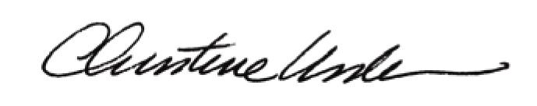

Date of Meeting: April 21, 2014 Title: Historic Officer

